Design Document
Table of Contents
- System Overview
- Implementation Details
- Use Case Support in Design
- Design Decisions

Writers
- Tenay Giray
- İpek Atak
- Defne Saracel
- Nehir Adak

- System Overview
Brief Project Description:
In this project we are aiming to raise environmental awareness with our mobile platform “Planeta”. Planeta is a mobile platform that tracks individuals’ daily activities with daily surveys. It provides appropriate feedback according to their answers and score. It helps users to see their progress with weekly/monthly reviews that encourage them to be more consistent with their act.

To keep users’ enthusiasm alive, beside score ranking system it also awards users with badges at milestones. Planeta offers simple user interface with dark/light mode switch option and daily enlightening quotes about nature.
It promotes sustainable use of natural resources in an interesting way.

System Architecture:
Planeta designed to follow a client-server model where the Flutter application acts as the client and Firebase acts as the server (BaaS). This serverless approach enables system to handle authentication and data storage in a simple way. The application is structured using a layered architecture that consists of 3 layers.
- Presentation Layer:
The user interacts with application through this layer. We decided to use Flutter to build our user interface. This layer handles UI, mode switching and local state management. It triggers authentication and data processes by communicating with the service layer.
- Service Layer:
This layer is the brain of the application; it acts like a bridge between presentation and database layer. It handles raw data to transform into meaningful results. This layer is responsible for score calculation, choosing accurate feedback according to result, controlling milestones and rank situations, business logic validation and so on.

- Database Layer:
For database layer we use “Cloud Firestore” a NoSQL document database. It helps system to store user profiles, daily survey results, earned badges and ranks while enabling real time updates. Service layer processes the data fetched from Firestore which resides here.

Component Diagram:
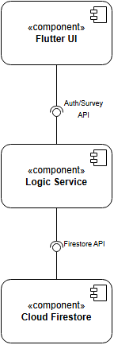

Deployment Diagram:
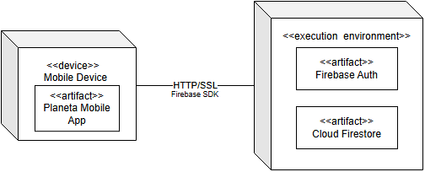

Technology Stack:
- Frontend Framework: Flutter
- Authentication System: Firebase Auth
- Backend / Database: Cloud Firestore
- State Management: Provider (Flutter Library)
- Design: Flutter (Material Design 3)
- Deployment: Android (APK) / IOS

- Implementation Details

2.1 Codebase Structure
“Planeta” will have three layers (Presentation, Service and Database Layer). The codebase structure:
lib/
├── main.dart # Firebase initialization + Provider setup
├── app.dart # MaterialApp configuration (routes, theme)

├── models/ # DATABASE LAYER – Firestore data models
│ ├── user_model.dart
│ └── survey_model.dart

├── services/ # SERVICE LAYER
│ ├── providers/ # state management
│ │ └── auth_provider.dart
│ │ └── survey_provider.dart
│ │ └── review_provider.dart
│ │

│ ├── auth/
│ │ └── auth_service.dart # login and register
│ │

│ ├── firestore/ # database access
│ │ └── user_service.dart
│ │ └── survey_service.dart
│ │
│ └── logic/
│ ├── score_calculator.dart
│ └── review_generator.dart

├── screens/ # PRESENTATION LAYER- UI screens
│ ├── auth/
│ │ ├── login_screen.dart
│ │ └── register_screen.dart
│ ├── home/
│ │ └── home_screen.dart
│ ├── survey/
│ │ └── survey_screen.dart
│ └── history/
│ └── history_screen.dart

├── widgets/ # PRESENTATION LAYER- reusable UI components
│ ├── common/
│ │ ├── custom_button.dart
│ │ └── theme_toggle.dart
│ ├── survey/
│ │ └── survey_question.dart
│ └── history/
│ │ ├── history_item.dart
│ │ └── badge_item.dart
└── utils/ # shared configurations and helpers
├── app_constants.dart
├── app_theme.dart
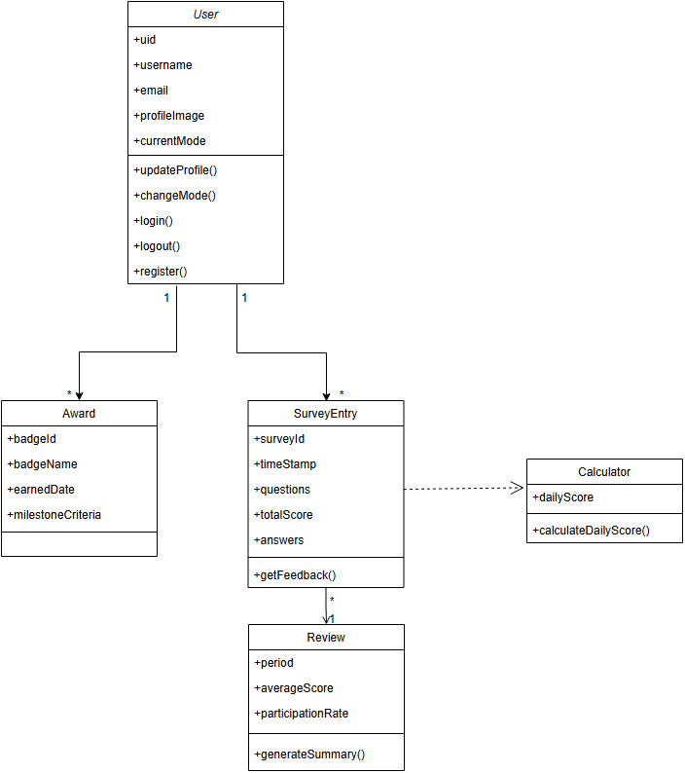

2.2 Key Implementations
This section describes the core logic and technical mechanisms for the functional requirements of Planeta application:
UI Layer → Service Layer → Firebase Backend

Hybrid Scoring and Feedback Engine:
This is the core business logic that processes daily surveys. It supports both binary (Yes/No) and Likert-scale (5 option) answers by assigning points (0/100 for binary answers ; 0,25,50,75,100 for Likert answers) to calculate a final sustainability score. Based on the result, it triggers a rule-based feedback system to provide users environmental advice.
finalScore = totalPoints / numberOfQuestions;

Award Logic:
This module manages the Award System by analyzing the user’s historical survey scores stored in the database. When the cumulative score reaches predefined thresholds, the system automatically grants the user a new rank. This ensures that users are rewarded for their long commitment and consistent sustainable performance over time. When predefined thresholds are reached, the user is automatically promoted to a higher sustainability rank.

Provider-Driven State and Theme Management:
Using the Provider pattern, the app manages real time state changes, such as survey progress and authentication status. It also handles the Dark/Light Mode toggle, ensuring visual integrity across different system themes.

Firebase Authentication and Profile Integration:
This module implements the logic for secure user registration and login functionality. We want users to be able to sign up for a new account and log in with their existing information.
History Tracking Management:
Every submitted survey is stored as a timestamped document in a Firebase. This architecture enables users to view their historical surveys, scores, and dates through the “User History” screen.
Each submitted survey is stored as a timestamped document under:
class SurveyEntry {
final String id;
final DateTime timestamp;
final Map<String, dynamic> answers;
final int score;
final String feedback;
}

2.3 Component Interfaces
1)Presentation Layer:
UI Components (Widgets):
- SurveyQuestionsWidget:
A reusable interface component that creates individual questions captures input according to the defined scaling system.

- CustomButton:
A standardized button used across Login,Register and survey screens for consistent UX.

2)Service Layer (SurveyProvider&AuthProvider):
This layer handles both the scoring algorithms and direct communication with the cloud backend. It eliminates the need of seperate Repository layer by utilizing the Firebase SDK directly.
- submitSurvey(Map<String,dynamic> answers):
Triggers the scoring algorithm(Hybrid Scoring) and generates feedback message based on the result. Calls SurveyRepository to persist the entry.

- loadHistory():
This function finds the user’s past survey results from Firestore. It organizes them from newest to oldest using timestamps and refreshes the list on the screen. After getting the data from the database, the app puts this new information into the list so the user can see it.

- Future<User> register( String email, String password, String username):
Calls Firebase Auth to create credentials and initializes a user a document in Firestore.

- Future<User> login( String email,String password):
Authenticates the user and detects the profile from users list.

- logout():
Clears the local session and returns the user to the Login screen.

Login, register, and logout operations are triggered from the Presentation Layer and handled by the Service Layer.

3) Cloud Database Layer (Serverless Backend)
For the database layer, the application utilizes Cloud Firestore, a serverless NoSQL database provided by the Google Firebase platform. It helps our system to store user profiles, daily survey results, earned badges, and ranks while enabling real-time updates.
Data Storage: Every survey the user completes is saved as a document with a timestamp in the cloud.
Direct Access: Our Service Layer talks directly to Firetore to save or reach data. We don’t choose using a separate Repository class; instead, we handle database tasks directly in our Service Layer.

2.4 Visual Interfaces
Login Screen:
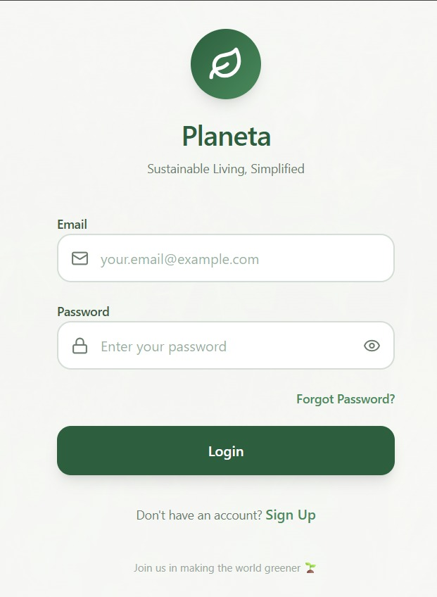
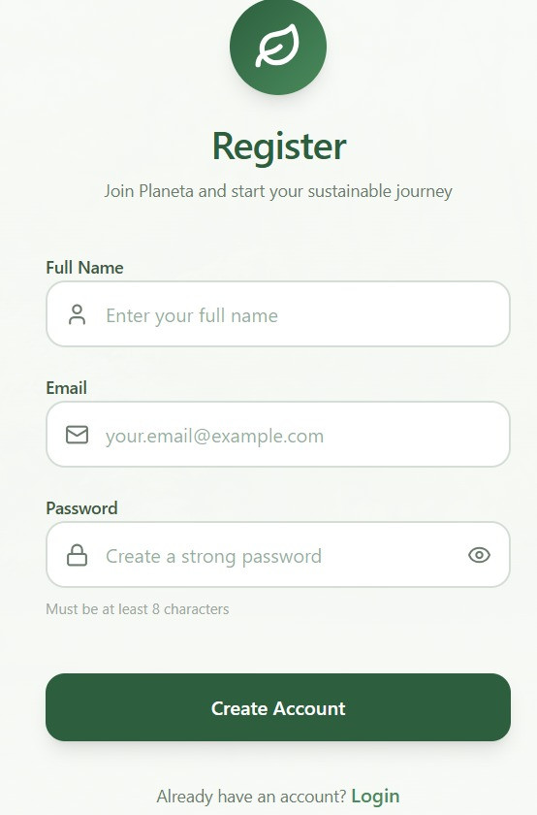
Register Screen:
Home Screen:
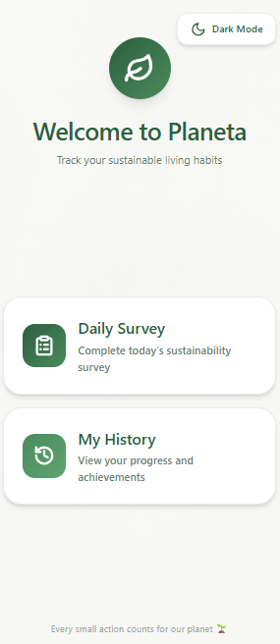
Survey Screen:
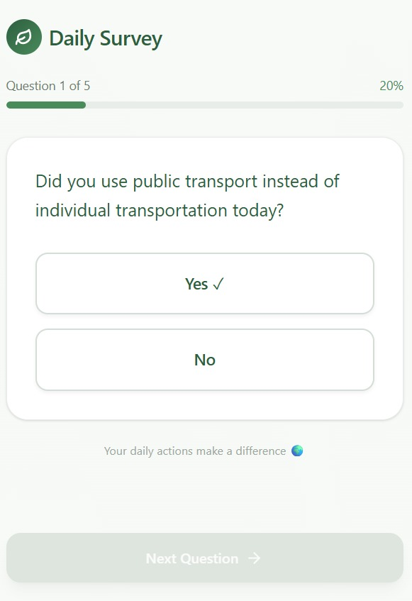
History Screen:
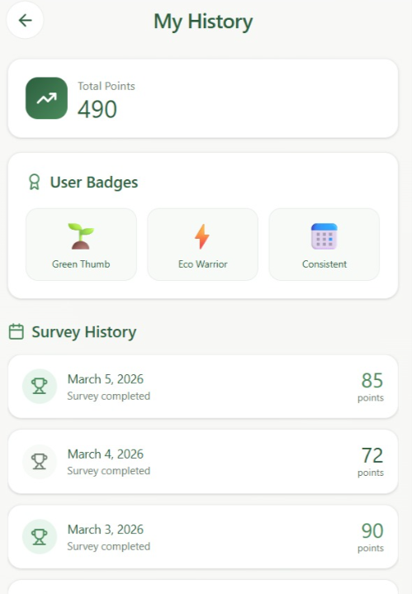
3)Use Case Support in Design
3.1 Use Case Selection:
- UC1 - User Registration(Sign Up)
- UC2 - User Login(User Authentication)
- UC3 - Daily Survey Submission + Providing Feedback
- UC4 - Survey History
3.2 Requirement Mapping:
 | Use Case | Requirements
UC1 | User Registration | - User Account
UC2 | User Login | - User Authentication
UC3 | Daily Survey Submission + Providing Feedback | - Daily Survey  - Feedback System
UC4 | Survey History | - Survey History

3.3 Use Case Desing:
The interaction pattern is consistent through out all the use cases,
Flutter UI -> Provider(Service Layer) -> Firebase Auth/Firestore -> Provider updates state -> UI refreshes
UC1 - User Registration(Sign Up): Create a new user account
System Architecture Support:
- Flutter UI (Register Screen) takes email/username/password.
- Auth layer (Firebase Auth) creates the user credentials.
- Data layer (Firestore) stores user profile document (username, email, createdAt).
Data Flow / Interactions: State Changes:
- App State: unauthenticated -> authenticated
- Database State: new document created in users collection for that uid.
UC2 - User Login (User Authentication): Login with existing credentials
System Architecture Support:
- Flutter UI (Login Screen) takes credentials.
- Firebase Auth verifies username/email and password.
- Provider updates app authentication state and current user data.
Data Flow / Interactions: State Changes:
- App State: unauthenticated -> authenticated
- Local State: Provider stores currentUserinformation

UC3 – Daily Survey Submission and Providing Feedback: Submit answers, compute score, show feedback, store result
System Architecture Support:
- Flutter UI (Daily Survey Screen) collects answers.
- Local Logic computes score and selects feedback message (rule based)
- Firestore stores survey entry.
Data Flow / Interactions:
State Changes:
- Database State: new survey document created under the user
- UI State: surveyNotSubmitted -> surveySubmitted
UC4 – Survey History: Displays previous surveys with date and score
System Architecture Support:
- History Screen requests past survey documents.
- Firestore query fetches survey entries
Data Flow / Interactions: State Changes:
- Database: Read Only
- Local State: Provider updates surveyHistoryList
3.4 Demo Requirement:
The four use cases as stated above will be fully implemented and demonstrated during the final project presentation.

4)Design Decisions
Technology Comparisons:
1)Flutter vs React Native

Feature | Flutter | React Native
Language | Dart | JavaScript
Performance | Very High | High
UI Design | Rich built-in widgets | Uses native components
Maintained by | Google | Meta
Object Oriented Programming | Fully object-oriented | Partially object-oriented
Architecture Comparison | Direct Native Compilation | Bridge Architecture
Hot Reload | Excellent | Good

Performance Advantage
Flutter provides higher performance compared to React Native because it uses its own rendering engine (Skia) and compiles directly into native code. This eliminates the need for a bridge between the application and native components. As a result, Flutter offers faster execution and smoother user experience.

Object Oriented Structure
Flutter uses Dart, which is a fully object-oriented programming language. This allows us to use principles such as: encapsulation, inheritance, abstraction and modularity. This improves code organization and maintainability. React Native useless JavaScript, which supports object-oriented programming but is not fully object-oriented and has a more flexible structure. Therefore, Flutter provides a more structured and maintainable codebase.

UI Consistency and Customization
Flutter uses its own widget system to render UI components. This ensures that the application looks consistent and pure across different platforms. React Native uses native UI components, which may behave differently depending on the platform. Therefore Flutter’s widget-based architecture provides better UI control, consistent design and easier customization for us while implementing Planeta.

Architecture
Flutter has a simpler architecture because it does not rely on a bridge. Instead, it communicates directly with the native platform. React Native requires a bridge between JavaScript and native code, which increases complexity and may reduce performance. We choose Flutter for simpler and more efficient architecture that improves performance, stability and development efficiency.

Hot Reload
Flutter provides a highly reliable and fast hot reload feature. It allows us to instantly see changes in the user interface without restarting the application. React Native also supports hot reload. However, it is less stable compared to Flutter and may sometimes require a full reload. In some cases, application state may not be fully preserved. Therefore, Flutter provides more efficient and reliable hot reload experience, which improves development speed and productivity.
OOP Comparison: Flutter vs React Native
Dart's classes allow for clear hierarchies and polymorphism:
abstract class PlanetaTask {
String title;
int getPoints(); // Abstract method
PlanetaTask(this.title);
}
// Inheritance and Implementation
class RecyclingTask extends PlanetaTask {
int weight;
RecyclingTask(String title, this.weight) : super(title);

@override
int getPoints() => weight * 10; // Specific logic for recycling
}
While you can use classes in JS/TS, the ecosystem leans heavily toward functional patterns:
// Usually defined as a Type or Interface in TypeScript
const calculatePoints = (taskType, value) => {
if (taskType === 'recycling') return value * 10;
return 0;
};
// Components are usually functions, not class objects
const TaskItem = ({ title, points }) => (
<View><Text>{title}: {points}</Text></View>
);
2) Firebase vs Supabase

Feature | Firebase | Supabase
Database Type | NoSQL | SQL
Open source | No | Yes
Relational data | Hard | Easy(supports foreign keys)
Real time updates | Excellent(Native feature) | Excellent
Security Modal | Firebase Security Rules(Custom) | Row Level Security(Standard SQL)
Vendor Lock In | High | Low

Open Source Status
While not open source, the Firebase Extensions and Documentation for pre-defined survey-style apps are extensive. This allows our group to implement the logic for "Fetching Questions -> Showing UI -> Saving Answers" faster than building a custom SQL schema from scratch.
Relational Data (Linking Survey Questions to Users)
We deliberately moved away from the high overhead associated with "JOIN" operations found in traditional relational databases (SQL). Instead, we utilized Firestore’s NoSQL document model to store data at /users/{uid}/surveys/{dateId} which prioritizes read speed and mobile responsiveness. Since Firestore queries scale with the size of the result set rather than the total dataset, our decision to use a hierarchical NoSQL structure ensures that our app remains fast and efficient even as the number of users and survey entries grows

Real-time Updates (Instant Feedback)
To support the gamification goals of the project—such as providing immediate feedback on a user's sustainability score—we leveraged Firebase’s native real-time listeners. When a user answers a pre-defined question, we want their score to update instantly. Firebase’s real-time listeners allow the UI to reflect the change the millisecond the data is written to the cloud.

Vendor Lock-in
While Firebase introduces a higher level of vendor lock-in due to its proprietary NoSQL structure and custom security rules, we prioritized development velocity for the Planeta project. To mitigate this lock-in, we decoupled our business logic into separate repository classes, ensuring that the UI and scoring algorithms remain portable even if a database migration is required in the future.

Task Matrix

- Tenay Giray | - System Overview
- İpek Atak | - Use Case Support in Design
- Defne Saracel | - Implementation Details, Design Decisions
- Nehir Adak | - Implementation Details, Design Decisions

